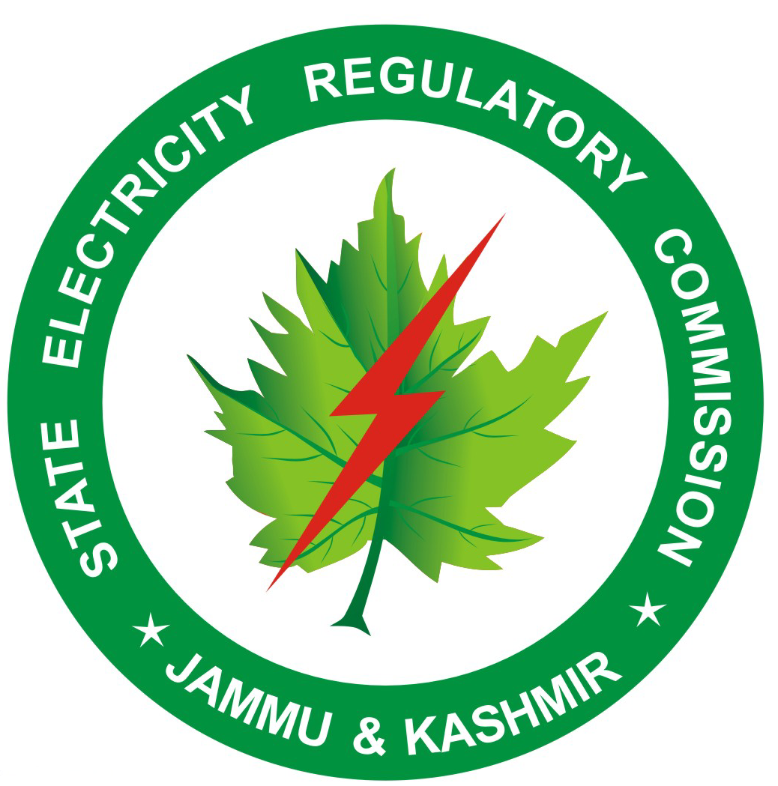
Jammu & Kashmir
State Electricity Regulatory Commission

Notification No. JKSERC/09 Date: 3rd January, 2011

Notification

In accordance with the provisions contained in Clause 5.1 of Jammu & Kashmir State Electricity Regulatory Commission (Renewable Purchase Obligation and its compliance) Regulations, 2010, the Jammu & Kashmir State Electricity Regulatory Commission, hereby designates the following as state Agencies for accreditation and recommending renewable energy projects in the State for registration and to undertake functions as provided in the Jammu & Kashmir State Electricity Regulatory Commission (Renewable Purchase Obligation and its compliance) Regulations, 2010.

1/. Jammu & Kashmir State Power Small Hydro Electric Projects
Development Corporation of above 2MW station capacity
in the State of Jammu & Kashmir

2/. Jammu & Kashmir Energy
Development Agency (JAKEDA) All renewable energy projects
other than Small Hydro Electric Projects of above 2MW station capacity
in the State of Jammu & Kashmir
excluding the Districts of Leh and Kargil.

3/. Ladakh Renewable Energy All renewable energy projects
Development Agency (LREDA) other than Small Hydro Electric Projects of above 2MW station capacity in the District of Leh.

4/. Kargil Renewable Energy All renewable energy projects
Development Agency (KREDA) other than Small Hydro Electric
Projects of above 2MW station
capacity in the District of Kargil.

Sd/-
No.: JKSERC/110/1182 Secretary
Dt: 03-01-2011 JKSERC

Copy forwarded for information and necessary action to:

1/. Managing Director, Jammu & Kashmir State Power Development Corporation, Jammu.

2/. Chief Executive Officer, Jammu & Kashmir Energy Development Agency (JAKEDA), Jammu.

3/. Chief Executive Councilor LAHDC, Leh.

4/. Chief Executive Councilor LAHDC, Kargil.

Copy for information to:

1/. Commissioner/Secretary to Government, Power Development Department.

2/. Commissioner/Secretary to Government, Science and Technology Department.

3/. Secretary, Central Electricity Regulatory Commission, New Delhi.

4/. Chief Executive Officer, Power System Operation Corporation Ltd. (NLDC), New Delhi.

5/. Development Commissioner, Power Development Department, Jammu.

